<http://www.dailytelegraph.com.au/news/opinion/tim-blair-britain-was-sick-of-the-eu-dictatorship/news-story/5a64316b1b2e8d2571e7f0f7f417dd11>

Opinion

# Tim Blair: Britain was sick of the EU dictatorship



Tim Blair, The Daily Telegraph

June 26, 2016 10:00pm

Subscriber exclusive



Last week’s Brexit vote in the UK was the finest nation-defending decision since the Manhattan Project was approved during World War II.

Not only has the rejection of Britain’s European Union membership commenced the UK’s restoration as an independent global power, but it is also serving as a brilliant sociological x-ray. In the wake of Brexit, we see the biases and prejudices of anti-democratic leftist snobs exposed in stunning, nuclear-lit clarity.

It was only a few years ago that leftists were demanding we pay attention to the incoherent whining of the Occupy movement. Their filthy tent cities represented the authentic voice of the people, apparently, and must be heeded.

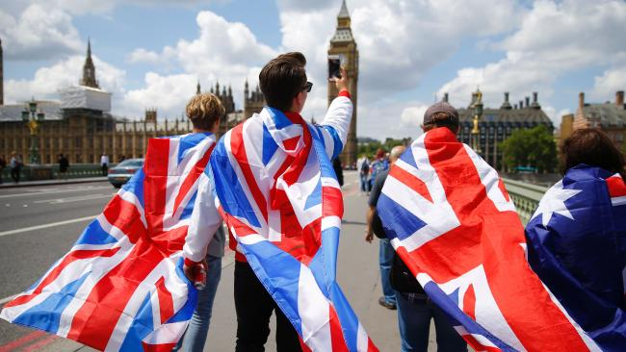People walk over Westminster Bridge wrapped in Union flags following the exit vote.

Yet when the people of Britain actually did have their say last Thursday, leftists were furious at the result and dismissed Leave voters as ignorant racist fools. “The chavs are going out all over Europe,” sneered the ABC’s Jonathan Green, “chavs” being the British equivalent of bogans.

“The truth is this is modern politics: ignorance masquerading as firm belief,” Green continued. “What does Leave actually mean? It’s a proxy for prejudice.”

Rejection of the EU actually meant that a majority of British voters were sick of being dictated to, on immigration and many other issues, by unelected EU clowns.

On the morning of the referendum, a Sydney mate called his Uncle Johnny in the UK to wish him a happy 90th birthday and to ask how his WWII paratrooper uncle would be voting.

“When I was 20 I dropped into France to stop the Germans taking over my country,” he replied, “so I thought I’d better have another go at stopping them now.” Then the war hero put on his overcoat, strode out into the West Yorkshire rain, and cast his vote. He’d be one of those ignorant, prejudiced “chavs” Green was talking about, I suppose.

“Brexit proves how dangerous the fear peddled by hyper-conservatives and anti-immigration parties can be,” Greens senator Sarah Hanson-Young babbled, although she was less concerned about danger following the deaths of 200 asylum seekers whose Australia-bound vessel sank in 2011. “Tragedies happen, accidents happen,” said Hanson-Young. So does democracy, Sarah. And it kills far fewer people.

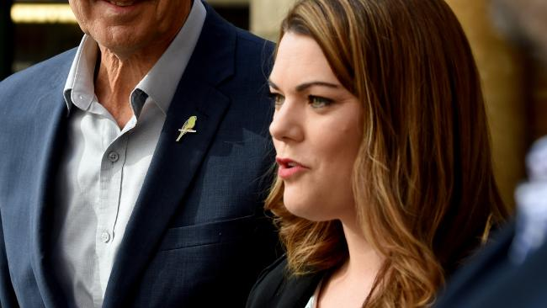Pro-Euro Senator Sarah Hanson-Young. Picture: Sam Wundke

It was touching to see a sudden concern from leftists about financial issues in the wake of the Leave vote’s success. “A billion dollars has wiped off the value of pension funds alone,” wept Guardian columnist Vanessa Badham. “Companies are withdrawing staff and investments. It’s huge.” Given that Badham is a Marxist, this represents something of a shift in values. Those poor, poor companies.

Asked on Twitter if he supported Brexit, Australian Republican Movement chairman Peter FitzSimons initially answered: “Nah”. This put him in the curious position of supporting Australian independence from the UK but opposing the UK’s independence from Brussels.

His outlook changed a little by the weekend, when the Fairfax columnist wrote: “I have no strong views one way or t’other on the virtues or otherwise of the Brexit. But say what you will, it bespeaks their confidence as a nation to go it alone, and that confidence is admirable.” FitzSimons attempted to spin this as a reason for the republican movement’s advance, but why would Australia want to sever ties with such a confident nation?

FitzSimons might do better by tying his cause to another independence movement: getting Australia out of the unrepresentative and invasive United Nations. Speaking of which, this was the Brexit reaction from the UN’s Special Representative for International Migration, Peter Sutherland:

“The younger generation in UK has been sacrificed all because of distortion of facts and consequences. Somehow this result must be overturned. I bet another vote tomorrow would be heavily in favour of staying in.”

That’s not how it works, dear fellow, although by yesterday some 2.6 million people had signed an online petition asking that “if the Remain or Leave vote is less than 60 per cent based on a turnout less than 75 per cent, there should be another referendum.” Too late, losers. The 52 per cent majority on a 72 per cent turnout stands.

Australians have never had a chance even once to vote for or against our entanglement with the UN. How about we give that a run before proceeding with a second Brexit referendum?

For that matter, maybe we could hold a Prexit poll to scrap media funding of the Press Council. And Toxic poll on placing a $40,000 cap on ABC presenter Tony Jones’s tax-provided salary. And a Kickit poll for Australian rules football clubs tired of the AFL’s ongoing transformation into a social justice movement with a sideline interest in holding occasional football matches.

It might be time for some of the wealthier clubs to cut loose from the AFL and establish their own rival league, free of social justice distractions. Naysayers may claim, however, that the logistics of such a move — splitting with TV contracts, locating match venues, obtaining sponsorship and so on — would make it all but impossible.

They should think again. Britain has withdrawn from Europe.

after that, anything is possible.